**INO GAMES QA TEST**Cauê Galli Miranda

**General QA Knowledge  
  
1. What is the primary purpose of Quality Assurance (QA)?**  
  
 The primary purpose of Quality Assurance is to ensure the quality of a product meets defined standards. This is done through systematic processes to ascertain that the product is in good shape before its release, preventing defects and aligning with users and other business requirements. Aside from bug finding, we can also give healthy feedback on the state of the product, helping developers get new and fresh perspectives in the development stage.

**2. What is the difference between a test case and a test plan?**

Test cases are specific instructions that we follow to ensure the functionality of a particular feature works as expected, for example a test case can involve buying currency. A test plan is a document that details the project as a whole such as the scope of the test, resources and how to approach it as well as its objectives, for example a test plan can involve outlining all requirements for a mobile app.

**3. What does the term 'regression testing' refer to?**  
 Regression testing refers to a method of testing that verifies if existing functionality remains unaffected after new updates or changes are added.   
 Example: The store menu of a game has been modified, we can test if the functionality of the store is intact and still works as expected after the changes have been made to it.  
  
**4. How would you create a template to describe bugs on a software that is being constantly released?**

It depends on the software and what kind of bug tracking tool the team would be using, but ultimately, I would create a template along the lines of:  
  
Title of the bug  
  
Description(Any videos, screenshots and logs would be added here):

Step by step:  
  
Expected behaviour:  
  
Actual behaviour:  
  
 As well as have fields in the template that can be filled with relevant information such as:  
  
Frequency:  
  
Severity:  
  
Device(s) Used:  
  
Version:  
  
Platform:  
  
Found by:  
  
Tags:  
  
Team to review:  
  
Reviewed in:  
  
**5. What is the importance of test automation in QA? What would you explore in terms of**

**automation for games being developed in a short period of time?** Automation in QA can be very beneficial, as it can save time by enabling faster and more efficient testing for specific important features in a more thorough way. This can optimize how much time is spent in a project and potentially make regression testing way easier, reducing possible human error and improving consistency.

I would firstly find out what changes the team can expect during development and then plan an automation around it. For example, we could have automated testing for HUD elements, that way we can always make sure the main clickable components in the screens are working, and then focus on the specifics of said components only, or for load testing and performance benchmarks.  
  
**6. Describe the main stages of the Software Testing Life Cycle (STLC).**1 - Requirement Analysis  
 Requirement Analysis is the first step of the STLC. The phase consists of an understanding of what needs to be tested and the requirements imposed. This step will make the team fully understand why a requirement is needed, if the quality will be affected by it, if it will be beneficial to the project and so on.

It can be functional or non-functional and the documents of the project as well as direct communication helps build a map for an analysis report and the development of a RTM (Requirement Traceability Matrix).

2 - Test Planning  
 Test Planning is the second step of the STLC. The phase consists of planning and defining how the test will be conducted, its scope and how the team will approach the project. A test plan document is then developed and it features the resources needed, time estimates, management of the project and so on.

3 - Test Case Development

Test Case Development is the third step of the STLC. The phase consists of creating a detailed test case and step by step methods based on the requirements previously seen. The test case will make it possible to track the data, make bug finding easier, test functionalities consistently and make it possible to start developing automation scripts based on the methods written.

4 - Test Environment Setup  
 Test Environment Setup is the fourth step of the STLC. The phase consists of preparing the environment to execute the tests. This involves downloading the needed software, applying necessary configurations, setting up needed hardware for testing and so on.  
  
5 - Test Execution  
 Test Execution is the fifth step of the STLC. The phase consists of executing the tests. It involves using all the previously prepared documents, test plan, test cases and executing for a quality analysis of the product, guaranteeing that its requirements are met for launch. Bug findings will also occur and will lead to reports potentially improving the quality of the product.  
  
6 - Test Closure  
 Test Closure is the sixth step of the STLC. The phase consists of finishing and analyzing the results of the tests. This will give us metrics that we can work with, logs for the developers, and general feedback of the product, preparing a final summary report of the cycle.  
  
**7. How would you handle a situation where a bug you reported is marked as 'not reproducible' by the development team?** Assuming every log, video and information possible was submitted with the bug report:It would depend on the severity of the bug and if I have time to explore more to try and find out if I can find reproducible steps, this would also involve talking directly with developers and collaborating to find potential specific causes. If I didn’t have time to study the bug or couldn’t learn its steps, I would then talk to the developers and head of the project to understand if the product can still be launched with the bug in it and if so, I would lower the severity of the bug. If it can’t be launched with the bug, I would give feedback regarding how the feature could be changed in order to prevent the bug from happening.  
  
  
**Hands-On Test**For the hands-on test, I will be using the following hardware:  
  
**Computer:**  
- Intel’s i5 12400f CPU  
- AMD’s RX 6600 GPU  
- 16GB 3200mhz of RAM  
- Windows 11 Home version 23h2  
  
**Mobile:**  
- Redmi 13C  
  
**Game:**- Esqueleto Explosivo 2  
  
  
  
  
  
  
  
  
  
  
- **Functional Testing:**  
**Verify that the game loads properly on different browsers (Chrome,**

**Firefox, Safari, Edge).**  
  
  
 The game loaded properly on Chrome, Firefox, Edge and Opera GX.  
  
 Firefox Microsoft Edge   
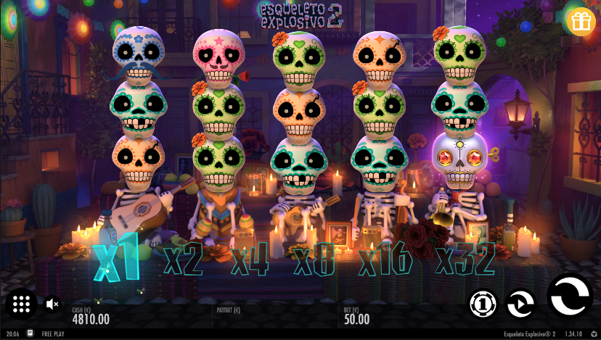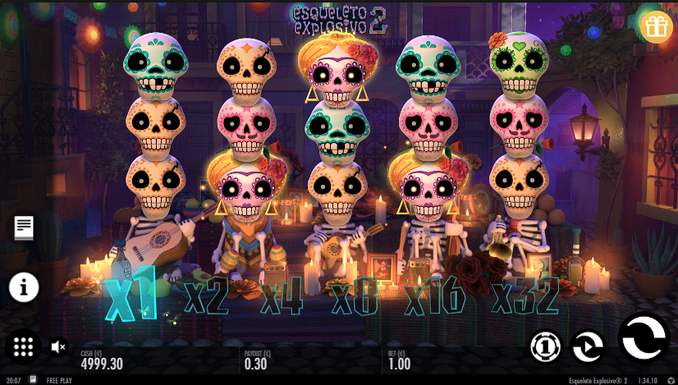  
 Google Chrome Opera GX

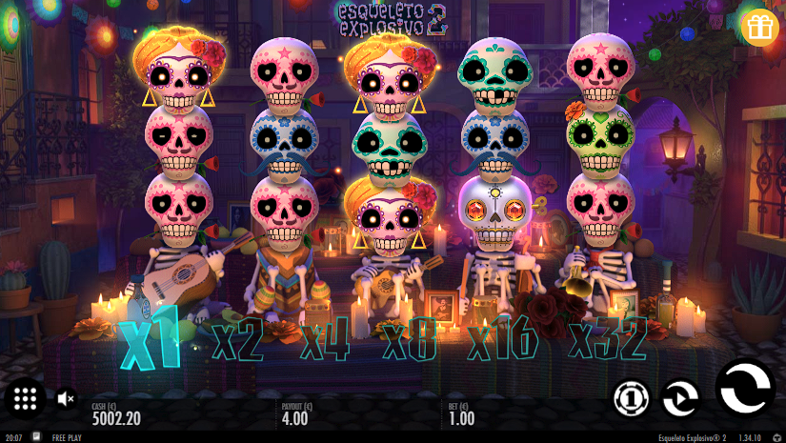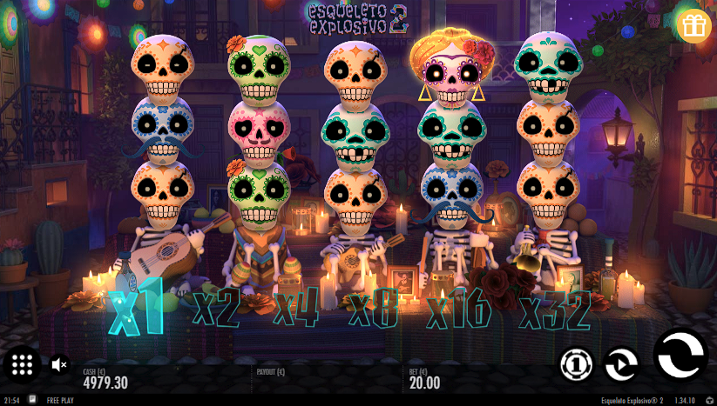

(Safari not available since I don’t have a MacOS based machine.)  
  
  
**Check that all buttons and controls (e.g., spin, bet, autoplay) function as expected.** - While all the buttons seemed to work, I ran into a problem where the sound button didn’t actually mute the whole game, only partial SFX. This only happened with Firefox, other browsers worked fine.

[**Firefox mute sound not working as expected.**](https://drive.google.com/file/d/11iYBfMND1dPp0C1uZr34N7kBCAwYQ-uh/view?usp=sharing)- I noticed that the page scroll actually scrolled the page even if I had the game in fullscreen mode. This happened with every browser **except** for Mozilla Firefox.  
  
[**Scroll wheel not functioning properly.**](https://drive.google.com/file/d/1tcKGnCKKASFHYzAVov8rHjkPUlzrdDeX/view?usp=sharing)

[**Firefox scroll wheel in comparison.**](https://drive.google.com/file/d/1t5LG3oVn-USUPHaTFPbByr3GD4C1v0FU/view?usp=sharing)

**Test the game for different bet amounts and ensure winnings are**

**calculated correctly.** - Since I don’t have a debug at hand, I tested every combination I got with every bet available to the player and everything seemed to be well calculated.  
  
**Verify that bonus features (if any) trigger and function correctly.**  
  
  
 - While the bonus round feature, explosivos wilds and scatter symbols triggered correctly, I couldn’t switch autoplay off during the bonus rounds. I don’t think this is correct since there’s nothing about forced autoplay on bonus rounds in the rules.  
  
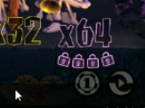  
  
[**Autoplay was forced on during bonus round.**](https://drive.google.com/file/d/1owwPgF8mgoMV6YSy1YiV3LKPWjtTFc4g/view?usp=sharing)  
  
  
  
  
  
  
 - Every time I pressed X to close full screen mode, I had to reload the game.  
  
[**Everytime full screen mode is closed, the game needs to be reloaded.**](https://drive.google.com/file/d/1qF7d4gTPIldap4K7-BHx6Cx3aQjUUQzi/view?usp=sharing) **Ensure that animations and graphics display correctly without glitches.** - The Scatter Symbol has a discrepancy in the rules and in-game.  
  
It has a red glow behind it in the rules.

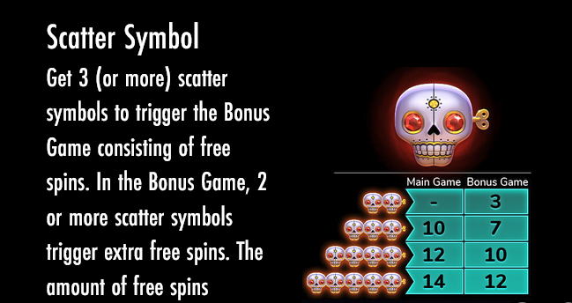  
While in-game, it has a purple glow behind it.  
  
  
  
  
- **Usability Testing:  
  
Evaluate the game’s user interface for ease of use.** -The user interface has some problems that I can address here.

If you open the game rules tab or the pay table tab, it’s possible to notice that some of the buttons overlap the text.  
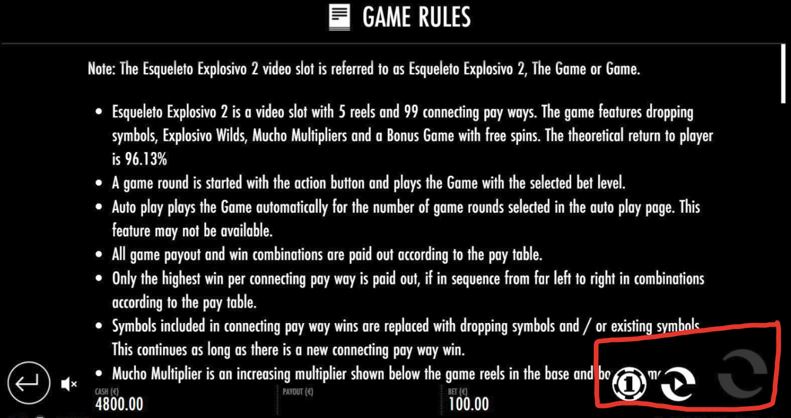

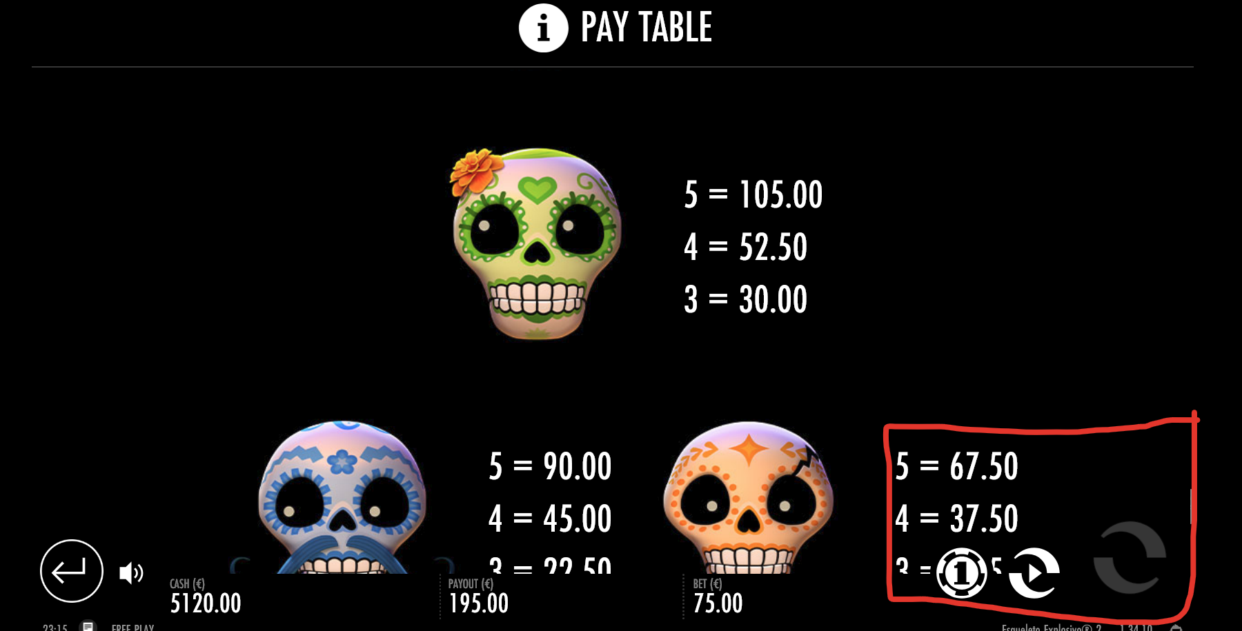

The “bet(€)” part of the UI does not look like a button and it took me a while to notice that I could click it. ****Every time the player chooses a number of game rounds to auto play, the tab instantly closes, so if I accidentally choose the wrong number I have to reopen the tab to choose another one.

[**Every time the player chooses an auto play number, the tab closes.**](https://drive.google.com/file/d/1kZFh5xEW6-8_WIigTnWz3q4SiEnCRcBs/view?usp=sharing)

Part of the UI could be a little bigger to accommodate vertical mobile devices, so that readability is not impaired.



**Test the game's responsiveness on different screen sizes (desktop, tablet, mobile).**

- Overall the game had expected behaviour while switching to different resolutions. Vertical is okay but landscape has a better experience since the UI is better distributed that way making everything more readable.

Galaxy S20 Landscape Mode

 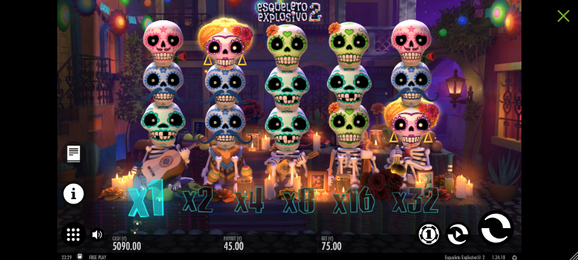  
  
 IPad Landscape mode  
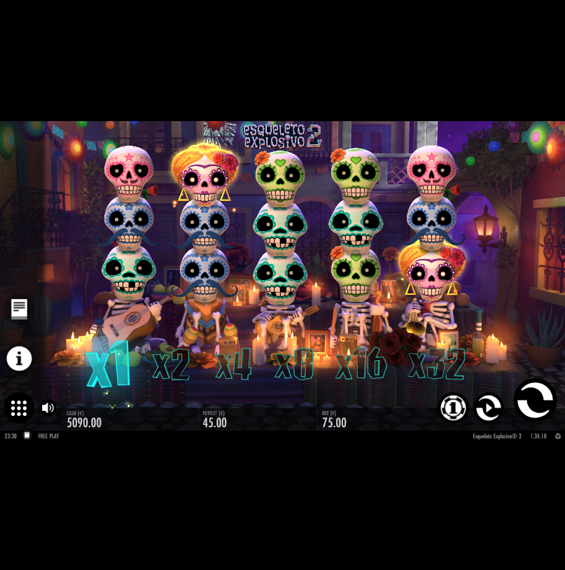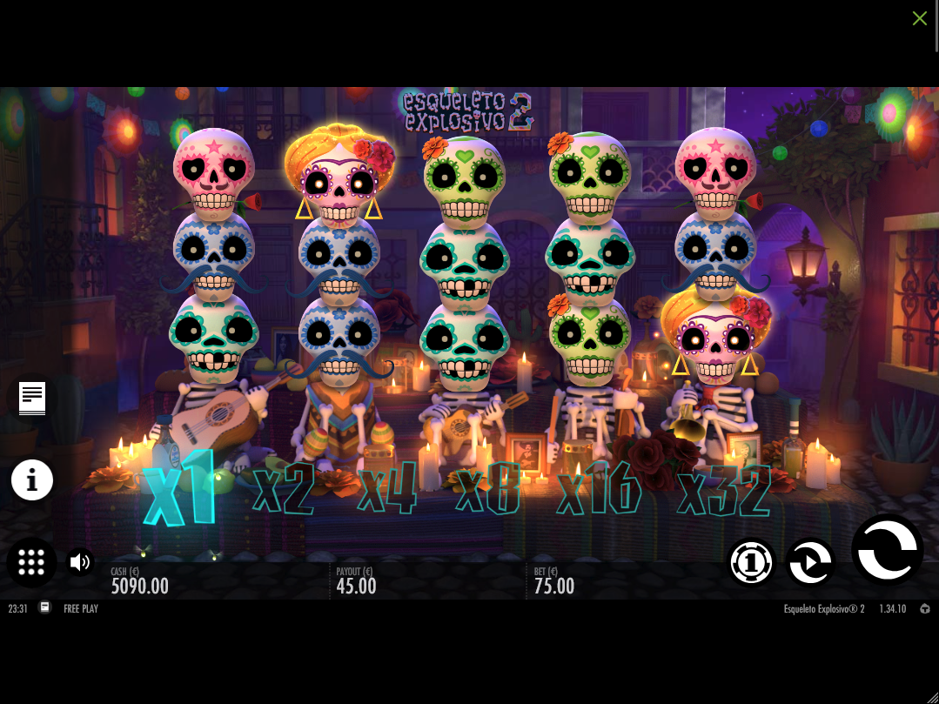

**- Performance Testing:**

**Monitor the game’s performance (e.g., loading times, frame rates) under normal and heavy loads.**

- Using Mozilla’s performance tool it’s possible to notice that during heavy load (skipping auto plays while Symbols explode) my cpu usage peaked at 85% which is quite high, I could notice a few mini stutters whenever that happened.

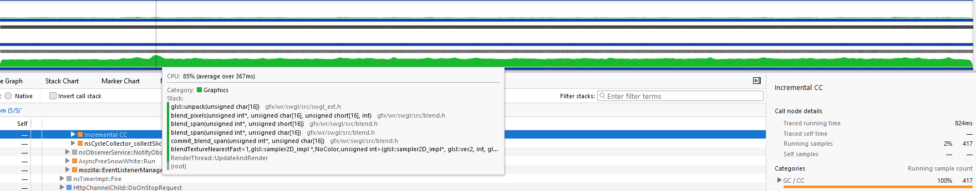

Still, the game performed quite well, having an average of 87 FPS during hours of testing. Temperatures were well controlled.  
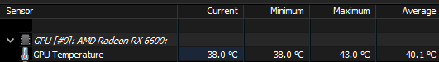  
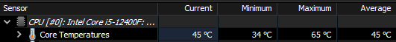  
  
  
  
  
  
  
  
  
  
  
  
  
  
**- Report Findings:** [**Firefox mute sound not working as expected.**](https://drive.google.com/file/d/11iYBfMND1dPp0C1uZr34N7kBCAwYQ-uh/view?usp=sharing)

Step 1 - Open the game with Mozilla Firefox.  
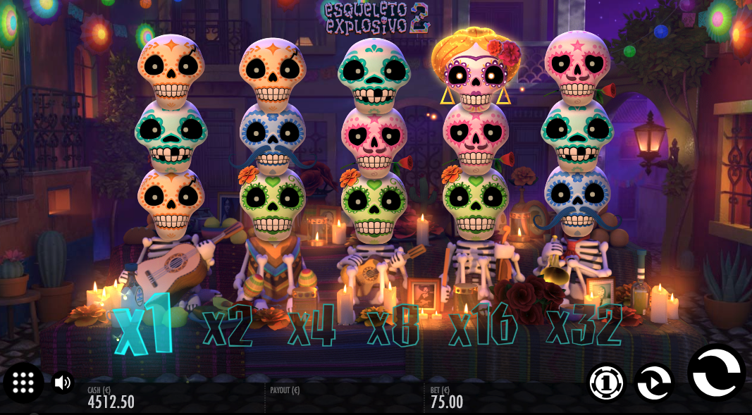

Step 2 - Click the mute button



Step 3 - Realize only the SFX have been muted.

Expected Result:

To mute the entire game.  
  
Actual Result:  
Muting the game partially.

Frequency - Always.

Severity - Normal.

Version: 1.34.10

**Reload Page is misspelled when leaving full screen mode.**

Step 1 - Enter the game in full screen mode.   


Step 2 - Click the green X on the top right corner.



Step 3 - Notice that the message it gives has “Reload” misspelled.



Frequency - Always.

Severity - Minor.

Version: 1.34.10

[**Autoplay was forced on during bonus round.**](https://drive.google.com/file/d/1owwPgF8mgoMV6YSy1YiV3LKPWjtTFc4g/view?usp=sharing)  
  
Step 1 - Enter bonus round.  
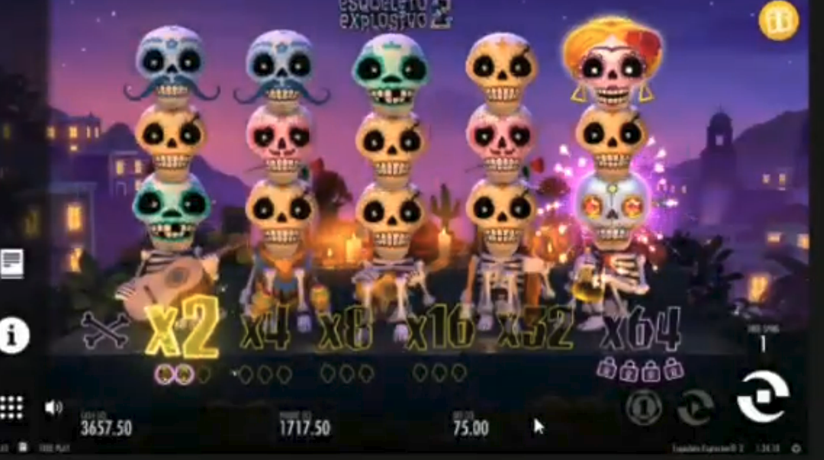

[SUGGESTION]Game shouldn't need to be reloaded verytime full screen mode is closed.Step 2 - Notice that autoplay is forced on and even if you stop it, you can’t play it manually.

Expected Result:

To be able to play it manually.  
  
Actual Result:  
Only autoplay is enabled.

Frequency - Always.

Severity - Major.

Version: 1.34.10

[**[SUGGESTION] Game shouldn't need to be reloaded verytime full screen mode is closed.**](https://drive.google.com/file/d/1qF7d4gTPIldap4K7-BHx6Cx3aQjUUQzi/view?usp=sharing)  
  
Step 1 - Enter full screen mode.



Step 2 - Close full screen mode.



Step 3 - Notice that the game needs to be reloaded now instead of continuing.



Expected Result:

For the game to continue open.  
  
Actual Result:  
Needs to be reloaded every time.

Frequency - Always.

Severity - Normal.

Version: 1.34.10

[**Scroll wheel not functioning properly.**](https://drive.google.com/file/d/1tcKGnCKKASFHYzAVov8rHjkPUlzrdDeX/view?usp=sharing)

Step 1 - Enter the game through any browser that is not Mozilla.

Step 2 - Enter full screen mode.



Step 3 - Notice that the rightmost scroll wheel actually scrolls the entire page even if you’re in full screen.

Expected Result:

For the scroll to be locked in full screen.  
  
Actual Result:  
It actually scrolls the page behind.

Frequency - Always.

Severity - Normal.

Version: 1.34.10

**- Submit Your Report:**

**Submit the report along with any additional notes or suggestions for**

**improvement.**

As someone who does not play casino games regularly, I found myself confused for a few minutes trying to understand how the rules of the game work. Something like a mini tutorial where you play a round and the game shows you what is going on would go a long way. There is a rule book but there is too much text to grasp everything, and a lot of the game wasn’t clear to me until I stopped to read it again.

Therefore I think the FTUE(First-Time User Experience) could be much improved, potentially increasing player engagement and session duration.

**- General Overview**

**Even though this is not a question, we’d like to hear why you selected this game. What are the ups and downs?**

I chose this game mainly because of its impressive visual design. The art team did an exceptional job with the visual appeal and interactivity of the game, it felt fun when all the Symbols started singing and then exploded. As someone with an artistic background, I enjoyed these elements.

However, the FTUE could be improved, my first experience was quite hard and took me a while to grasp everything and every rule.

**What would you consider a factor that would make you play again?**

I would likely return if the game introduced more strategic mechanics or gameplay variations that encouraged thoughtful betting decisions based on the situation.

**Was this an engaging experience?**

Definitely, testing a casino game posed unique challenges that pushed me to approach testing from a fresh perspective. I felt like I was learning a lot and using new ways to test things making everything more engaging than usual.